**Project Development Phase Sprint 3**

|  |  |
| --- | --- |
| Team ID | PNT2022TMID13652 |
| Project Name | Smart waste management system for metropolitan cities |
| Maximum Marks | 8 Marks |

**USING NODE RED:**

Creating NODE RED FLOWS:

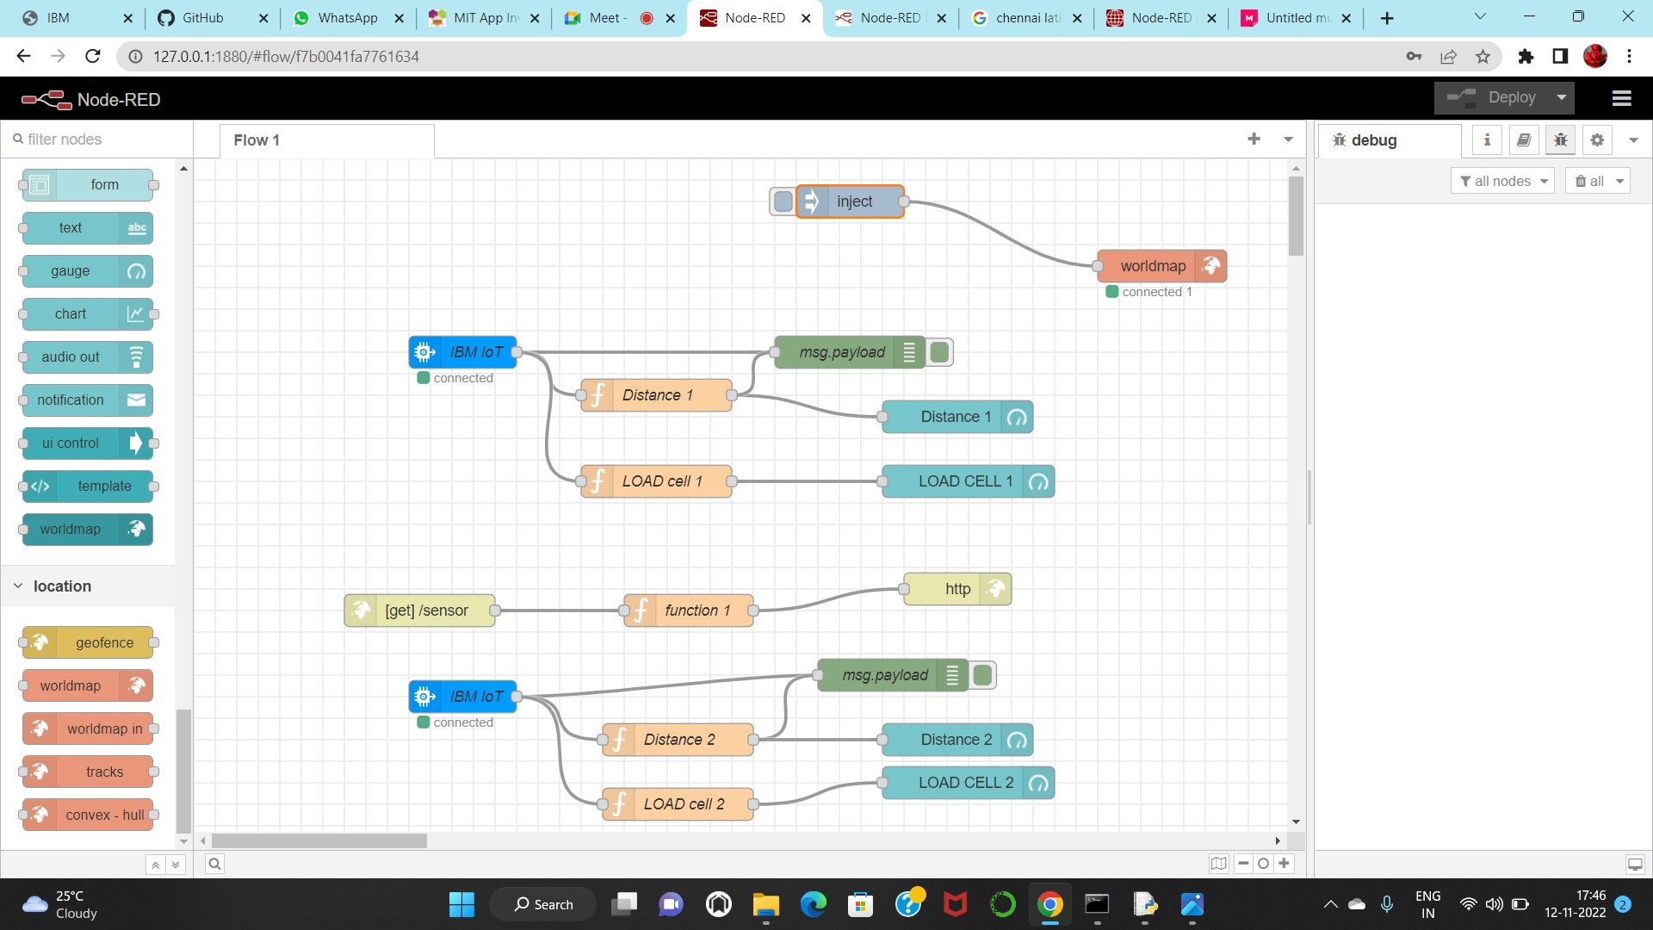

Creating NODERED UI:

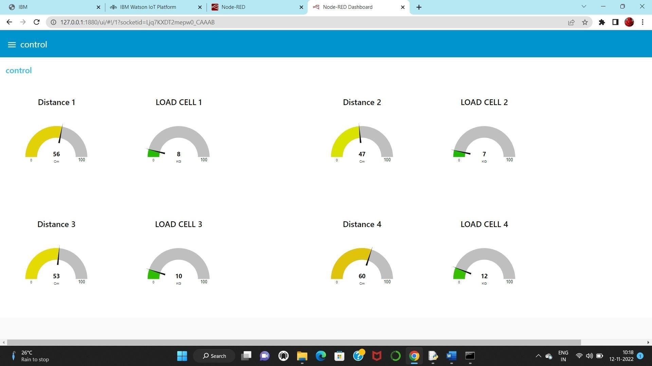­­­

LOCATION TRACKER:

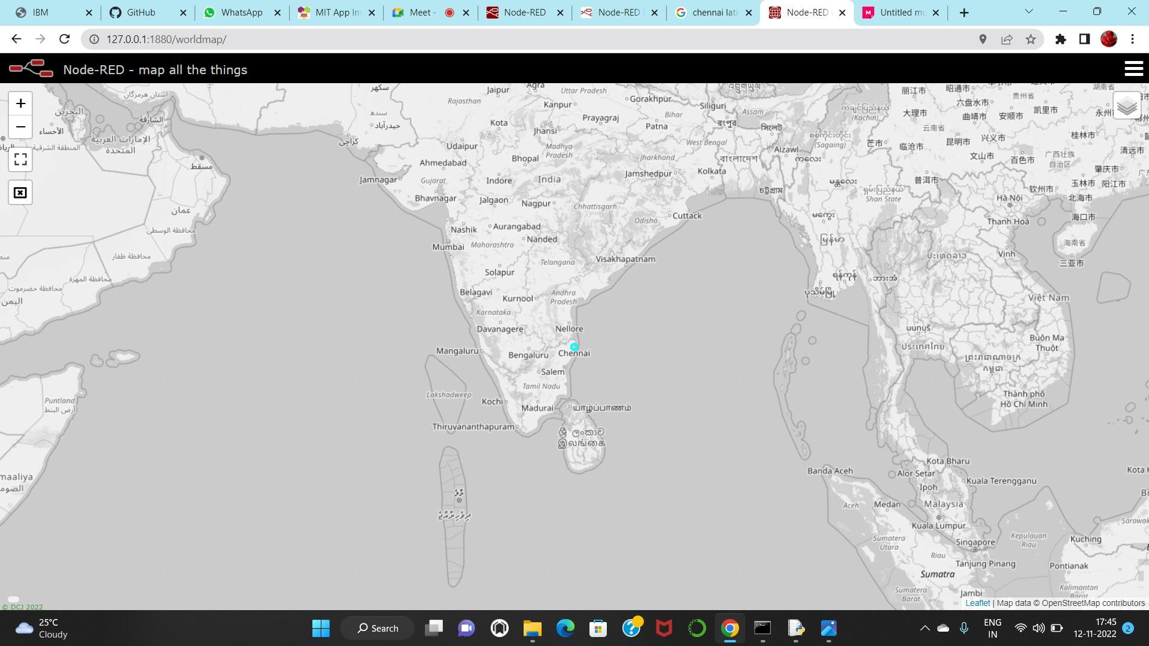

**CONCLUSION:**

In sprint 3, we created node red flow by using IBM cloud service and also we created node red user interface which helps in location tracker that will helps us to find the current exact location of the dustbin which helps the sanitary workers to collect the trash when it is needed.